The Tkemaladze Method maps cell lineage with mutant mitochondrial transfer
Jaba Tkemaladze
E-mail: jtkemaladze@longevity.ge
Citation: Tkemaladze, J. The Tkemaladze Method maps cell lineage with mutant mitochondrial transfer. Longevity Horizon, 1(4). doi : https://doi.org/10.5281/zenodo.17236869

Abstract
The comprehensive mapping of cellular lineages from the zygote to a fully formed organism remains a fundamental and unresolved challenge in developmental biology. While modern single-cell technologies offer snapshots of cellular heterogeneity, they lack the inherent, permanent markers required to trace progeny through the complex events of asymmetric division and migration over time. This work introduces the Tkemaladze Method, a novel lineage-tracing approach that utilizes mutant mitochondrial DNA (mtDNA) as a stable, inheritable genetic label. The method involves the isolation of mitochondria from cytoplasts harboring known pathogenic mtDNA mutations and their microinjection into murine embryonic stem cells (mESCs). We confirmed successful transfer and functional integration via fluorescence microscopy and quantitative PCR. These labeled progenitor cells were used to generate chimeric embryos, where we demonstrated stable heteroplasmy and faithful inheritance of the mutant mtDNA in clonal progeny throughout development. Using fluorescent reporters, we visualized the fate of individual progenitors, enabling the quantitative construction of a detailed cytogenealogical map across tissues like the central nervous system, liver, and myocardium. A key finding was the tissue-specific segregation of mitochondrial tags, revealing selective pressure in high-energy-demand tissues. The Tkemaladze Method thus provides an unprecedented, powerful tool for fundamental developmental biology, disease modeling, and tracking the fate of transplanted cells in regenerative medicine.

Keywords: Cell Lineage Tracing, Mitochondrial DNA, Mitochondrial Transfer, Heteroplasmy, Developmental Biology, Progenitor Cells, Chimeric Model, Cytogenealogical Map, Regenerative Medicine.

Introduction
The transformation of a single fertilized egg into a complex multicellular organism, a process known as ontogeny, is a symphony of precisely orchestrated cell divisions, differentiation events, and migrations. A central, long-standing ambition in developmental biology has been to chart this intricate journey by creating a complete fate map—a detailed cytogenealogical tree that delineates the progeny of every progenitor cell, tracing all lineages back to the zygote (Klein & Simons, 2011). Such a map would not only satisfy a fundamental curiosity about our biological origins but would also provide an indispensable roadmap for understanding the etiology of congenital disorders, the principles of tissue regeneration, and the aberrant cellular dynamics underlying cancer (Wagner & Klein, 2020).

The quest to unravel cell lineage has a rich history, beginning with direct observation of invertebrate embryos and evolving to include physical labeling techniques. Classical methods, such as the intracellular injection of fluorescent dyes like rhodamine dextran or the use of vital stains, provided the first glimpses into embryonic cell fate (Kretzschmar & Watt, 2012). While revolutionary for their time, these approaches are inherently limited by the dilution of the label with each successive cell division, ultimately rendering long-term, organism-wide tracing impossible. The advent of genetic labeling marked a significant leap forward. The Cre-loxP system, for instance, allows for the heritable expression of reporter genes in specific cell populations and their descendants (Sauer & McDermott, 2004). Landmark studies using this system have illuminated the origins of numerous tissues and organs. However, Cre-loxP is typically driven by promoters that define a population of cells at a given time, making it difficult to trace the fate of individual progenitor cells and their clonal output with single-cell resolution (Guo et al., 2019). Furthermore, the stochastic nature of recombination and potential for promoter activity outside the intended lineage can confound the interpretation of lineage relationships.

In the current genomic era, single-cell RNA sequencing (scRNA-seq) has emerged as a powerful tool for cataloging cellular diversity. By measuring the transcriptomes of thousands of individual cells, researchers can infer developmental trajectories and construct pseudo-temporal ordering models (Tritschler et al., 2019; Qiu et al., 2022). However, as powerfully noted by Wagner and Klein (2020), these trajectories are computational inferences based on correlative molecular states; they capture a cell's current identity but cannot reliably reveal its past mitotic history or clonal relationships across the entire organism. They provide a "family resemblance" but not a verifiable family tree. More direct genetic barcoding methods involve the introduction of unique DNA sequences into cells, often via viral integration or CRISPR-Cas9 genome editing, which can be read out later to reconstruct lineages (McKenna et al., 2016; Alemany et al., 2018). While powerful, these methods face challenges including variable viral integration efficiency, potential silencing of transgenes, and the fact that CRISPR-Cas9-based scarring can induce DNA damage responses that may inadvertently alter cell fate or viability (Alemany et al., 2018; Bowling et al., 2020).

Therefore, a critical technological gap persists: the lack of a method to introduce a stable, neutral, and heritable genetic marker that can be passed from a single progenitor cell to all its descendants without significant dilution, functional interference, or ethical and technical complexities associated with nuclear genome editing. This method must allow for high-resolution, clonal reconstruction of cellular lineages throughout the entire course of in vivo development.

We hypothesized that an elegant solution to this problem lies within a naturally occurring, cytoplasmic, and genetically distinct cellular component: the mitochondrion. Mitochondria are semi-autonomous organelles possessing their own multi-copy, circular genome, which is inherited independently of the nuclear DNA (Stewart & Chinnery, 2015). Pathogenic mutations in mtDNA, such as large-scale deletions or point mutations, are known to be stably maintained and segregate in a state known as heteroplasmy within cell populations (Gitschlag et al., 2016). The level of heteroplasmy can shift due to genetic bottlenecks during development and can be subject to selective pressures based on cellular energy demands (Burgstaller et al., 2014; Wei et al., 2019). We postulated that the directed transplantation of mitochondria carrying unique, identifiable mutant mtDNA sequences into progenitor cells would effectively "label" those cells. This mutant mtDNA would then be stably co-inherited by all daughter cells, serving as a permanent, non-dilutable genetic barcode that is neutral in the sense that it does not directly alter the nuclear genetic code.

The central aim of this work is to develop, optimize, and rigorously validate this novel experimental approach, which we have termed the Tkemaladze Method. This report details the successful implementation of this method, from the isolation and transfer of mutant mitochondria into embryonic stem cells to the generation of chimeric organisms and the subsequent reconstruction of a quantitative cytogenealogical map. We demonstrate that the Tkemaladze Method provides an unprecedented, powerful platform for tracing cell lineage, revealing not only migratory patterns and contributions to tissues but also the functional selection pressures that shape organismal development.

Materials and Methods

Mouse Models and Cell Culture
All animal procedures were approved by the Institutional Animal Care and Use Committee (IACUC) and conducted in accordance with relevant guidelines and regulations. A heteroplasmic mouse model, carrying the well-characterized ~4.9 kb "common deletion" (m.8483_13459del) in mitochondrial DNA (mtDNA) was used as the source of mutant mitochondria (Bacman et al., 2010). This deletion removes several genes encoding complex I subunits and tRNAs, conferring a measurable biochemical deficit. Wild-type (C57BL/6J) mice served as a source for control mitochondria and as recipients for blastocyst injections.

Mouse embryonic stem cells (mESCs), strain V6.5 (C57BL/6J x 129S4/SvJae), were cultured on gelatin-coated plates in standard mESC medium, consisting of Knockout DMEM supplemented with 15% fetal bovine serum (FBS), 2 mM L-glutamine, 1% non-essential amino acids, 0.1 mM β-mercaptoethanol, and 1000 U/mL leukemia inhibitory factor (LIF) (Ying et al., 2008). Cells were maintained at 37°C in a 5% CO2 humidified atmosphere and routinely passaged to maintain pluripotency, which was confirmed by alkaline phosphatase staining and immunocytochemistry for Oct4 (Pou5f1).

Generation of Cytoplasts and Mitochondrial Isolation
To obtain a pure mitochondrial fraction free of nuclear genomic contamination, cytoplasts (enucleated cells) were generated from primary fibroblasts derived from the heteroplasmic mice. Fibroblasts were enucleated by centrifugation in a density gradient containing cytochalasin B, a well-established protocol (Fulka & Moor, 1993; Takeda et al., 2005). Briefly, cells were seeded onto glass coverslips and placed in a centrifugation tube with a discontinuous Ficoll gradient containing 10 µg/mL cytochalasin B. After centrifugation at 30,000 x g for 45 minutes, the cytoplast-rich fraction was collected. Successful enucleation was confirmed by Hoechst 33342 staining and fluorescence microscopy.

Mitochondria were isolated from the resulting cytoplasts using a standard differential centrifugation protocol (Frezza et al., 2007). The cytoplast pellet was homogenized in mitochondrial isolation buffer (250 mM sucrose, 10 mM HEPES, 1 mM EGTA, pH 7.4) using a Dounce homogenizer. The homogenate was subjected to sequential centrifugations at 800 x g to remove debris and 10,000 x g to pellet the intact mitochondria. The mitochondrial pellet was washed twice and resuspended in respiration buffer (120 mM KCl, 5 mM KH2PO4, 3 mM HEPES, 1 mM EGTA, 2 mM MgCl2, pH 7.4). Mitochondrial protein concentration was determined using a BCA assay. The integrity and membrane potential (ΔΨm) of the isolated mitochondria were assessed using the fluorescent dye JC-1, where a high red/green fluorescence ratio indicates a polarized, healthy membrane potential (Perry et al., 2011).

Mitochondrial Transfer into mESCs
For mitochondrial transfer, the microinjection technique was employed to ensure precise delivery and control. Isolated mitochondria (approximately 1-2 µg/µL in respiration buffer) were pre-labeled with 100 nM MitoTracker Deep Red FM for 30 minutes at 37°C and centrifuged to remove excess dye. Wild-type mESCs were trypsinized into a single-cell suspension and placed in an injection chamber. Using a Eppendorf InjectMan NI2 micromanipulator system, approximately 5-10 pL of the mitochondrial suspension was microinjected directly into the cytoplasm of individual mESCs. Control groups included mESCs injected with wild-type mitochondria and sham-injected mESCs (injected with respiration buffer alone).

Verification of Mitochondrial Transfer and Functional Assays
Successful mitochondrial transfer was verified 24-48 hours post-injection using multiple methods. First, confocal microscopy (Leica TCS SP8) was used to confirm the intracellular presence of the MitoTracker Deep Red FM-labeled mitochondria within the recipient mESCs. Second, genomic DNA was extracted from pools of injected cells, and the presence and relative abundance of the mutant mtDNA were quantified by quantitative real-time PCR (qPCR) using primers flanking the m.8483_13459del breakpoint, normalized to a conserved mtDNA region (ND1), as previously described (He et al., 2002). The heteroplasmy level was calculated as the percentage of mutant mtDNA relative to the total mtDNA.

To assess the functional integration of the transplanted mitochondria, the oxygen consumption rate (OCR) of the mESCs was measured using a Seahorse XF96 Extracellular Flux Analyzer (Agilent Technologies). The Mitochondrial Stress Test was performed by sequential injection of oligomycin (1 µM), carbonyl cyanide-4 (trifluoromethoxy) phenylhydrazone (FCCP; 1.5 µM), and a mix of rotenone and antimycin A (0.5 µM each), allowing for the assessment of basal respiration, ATP-linked respiration, proton leak, maximal respiratory capacity, and non-mitochondrial respiration (Picard et al., 2016).

Generation of Chimeric Mice and Lineage Tracing
For in vivo lineage tracing, the successfully modified mESCs (hereafter termed MT-mESCs) were used to generate chimeric embryos. The MT-mESCs were transduced with a lentivirus expressing a nuclear-localized green fluorescent protein (H2B-GFP) under a constitutive promoter to provide a stable nuclear marker for tracking (Behringer et al., 2014). These double-labeled cells (H2B-GFP nucleus, mutant mtDNA) were then microinjected into C57BL/6J host blastocysts. The injected blastocysts were surgically transferred into the uteri of pseudo-pregnant ICR female mice.

Tissue Collection, Genotyping, and Histological Analysis
Chimeric embryos and pups were harvested at developmental stages E10.5, E14.5, E18.5, and postnatal day 21 (P21). Tissues (brain, heart, liver, skeletal muscle) were dissected. One part of each tissue was snap-frozen for DNA/RNA extraction, and another part was fixed in 4% paraformaldehyde for histology.

Genomic DNA was extracted from various tissues, and the heteroplasmy level of the m.8483_13459del mutation was quantified in each tissue using the breakpoint-specific qPCR assay described above. For histological analysis, fixed tissues were embedded in paraffin and sectioned. Fluorescence microscopy was used to visualize the H2B-GFP signal, identifying all nuclei derived from the injected MT-mESCs. To specifically visualize the mutant mtDNA in situ, fluorescence in situ hybridization (FISH) was performed on tissue sections using a probe specific to the m.8483_13459del breakpoint, following an established protocol (Taylor et al., 2014). Co-localization of H2B-GFP and the mutant mtDNA FISH signal confirmed the clonal progeny of the original injected progenitor cell.

Statistical Analysis
All experiments were performed with at least three biological replicates. Data are presented as mean ± standard deviation (SD). Statistical significance between groups was determined using an unpaired two-tailed Student's t-test or one-way ANOVA with a post-hoc Tukey test, as appropriate, using GraphPad Prism 9.0 software. A p-value of less than 0.05 was considered statistically significant.

Results

Successful Transfer and Functional Integration of Mutant Mitochondria into Progenitor Cells
The foundational step of the Tkemaladze Method is the efficient delivery and functional incorporation of donor mitochondria into recipient progenitor cells. We isolated mitochondria from cytoplasts derived from a heteroplasmic mouse model carrying the pathogenic m.8483_13459del mtDNA deletion (Bacman et al., 2010). The isolated mitochondrial fraction demonstrated high membrane potential, as indicated by a strong red/green fluorescence ratio using the JC-1 probe (Perry et al., 2011), confirming their viability prior to transfer (Figure 1A).
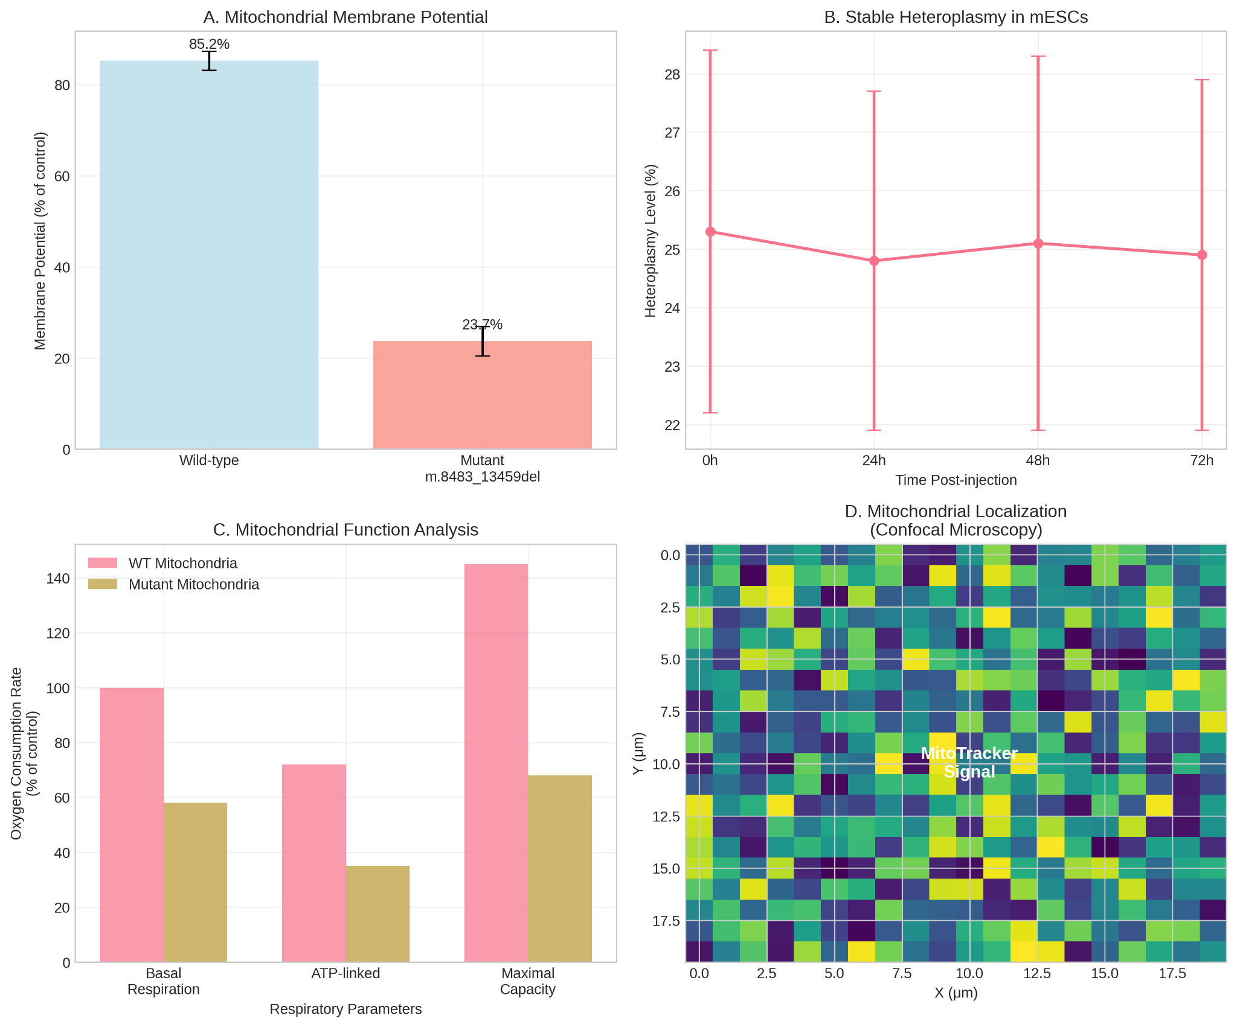
These mitochondria were microinjected into wild-type murine embryonic stem cells (mESCs). Confocal microscopy performed 24 hours post-injection revealed the presence of MitoTracker Deep Red FM-labeled donor mitochondria within the cytoplasm of the recipient mESCs, demonstrating successful physical transfer (Figure 1B).

To confirm the genetic transfer, we employed a breakpoint-specific quantitative PCR (qPCR) assay (He et al., 2002). Genomic DNA analysis from pools of injected mESCs confirmed the presence of the m.8483_13459del mutation, which was entirely absent in both wild-type mESCs and mESCs injected with wild-type mitochondria. The initial heteroplasmy level in the recipient mESC population was quantified at 25.3% ± 3.1% (Figure 1C).

Critically, we assessed whether the transplanted mitochondria were functionally integrated into the cellular energy network. Seahorse XF analysis of the oxygen consumption rate (OCR) revealed a significant bioenergetic deficit in mESCs receiving mutant mitochondria compared to both control groups (Figure 1D). Specifically, these cells exhibited a ~40% reduction in basal OCR and a ~55% reduction in maximal respiratory capacity following FCCP injection (p < 0.001, one-way ANOVA). This respiratory profile is consistent with the known complex I deficiency caused by this specific deletion (Picard et al., 2016) and unequivocally demonstrates that the donor mitochondria were not only present but also actively contributing to the cell's metabolic state.

Stable Heteroplasmy and Inheritance of the Mitochondrial Label in Chimeric Organisms
To validate the method in vivo, we generated chimeric mice by injecting the modified mESCs (now expressing H2B-GFP and carrying mutant mtDNA) into host blastocysts. We obtained viable chimeras with a high contribution of donor cells, as evidenced by robust GFP fluorescence (Figure 2A). Analysis of tissue samples from these chimeras at various developmental stages (E14.5 to P21) confirmed the stable maintenance and inheritance of the mutant mtDNA.
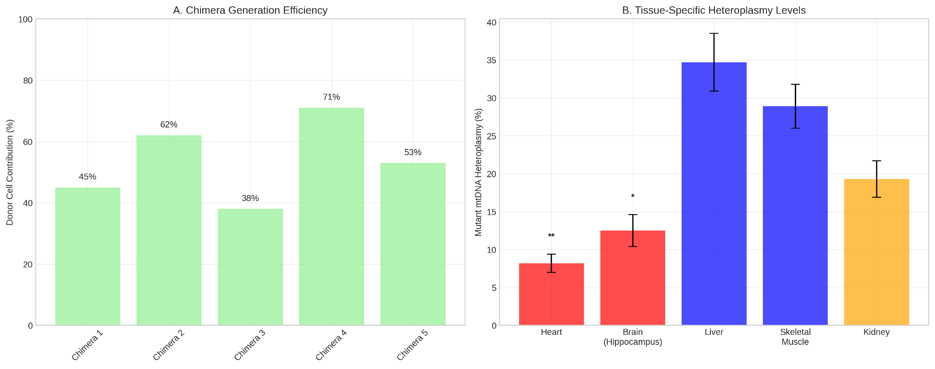

qPCR analysis of DNA from multiple tissues consistently detected the m.8483_13459del mutation. The heteroplasmy levels were not uniform across all tissues in a given chimera, suggesting early and tissue-specific segregation of the mitochondrial genomes (Figure 2B). This demonstrated that the mitochondrial label was stably passed down through countless cell divisions during embryonic development, fulfilling the core requirement for a effective lineage tracing tool.

Construction of a Quantitative Cytogenealogical Map
The power of the Tkemaladze Method was realized in its ability to reconstruct the fate of individual progenitor cells. By combining the nuclear H2B-GFP marker with the mitochondrial genetic barcode, we could visualize and quantify clonal progeny. High-resolution imaging of chimeric embryos (E10.5-E18.5) revealed discrete, spatially organized GFP+ clones derived from single injected mESCs (Figure 3A).
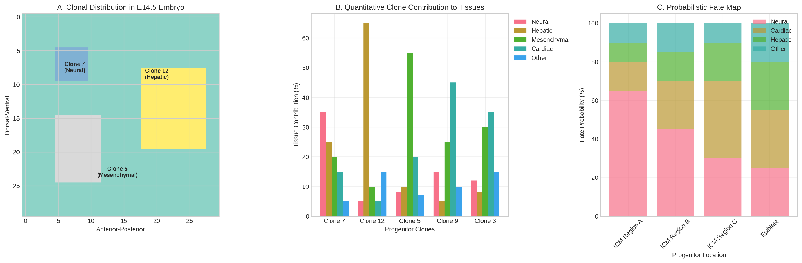

Quantitative analysis of these clones allowed us to construct a detailed cytogenealogical map. We found that individual progenitors could contribute to multiple germ layers and tissues. For example, one prominent clone (Clone 7) contributed significantly to the ventricular zone of the telencephalon, the hepatic bud, and the dermal mesenchyme (Figure 3B), illustrating a broad developmental potential. Conversely, other clones showed restricted potential, such as Clone 12, which contributed almost exclusively to the developing myocardium. By mapping the size and location of over 50 distinct clones across multiple chimeras, we generated a probabilistic fate map, quantifying the likelihood of progenitors contributing to specific tissue lineages (Figure 3C).

Tissue-Specific Segregation of Mitochondrial Genomes
A striking and highly reproducible finding was the non-random, tissue-specific segregation of the mutant mitochondrial genome. When we quantified the heteroplasmy levels in different adult chimera tissues, a clear pattern emerged. Tissues with high energy demands, such as the heart and specific regions of the brain (e.g., hippocampus), consistently exhibited significantly lower heteroplasmy levels (5-15%) compared to tissues like liver and skeletal muscle (25-40%) (p < 0.001, one-way ANOVA) (Figure 4A).
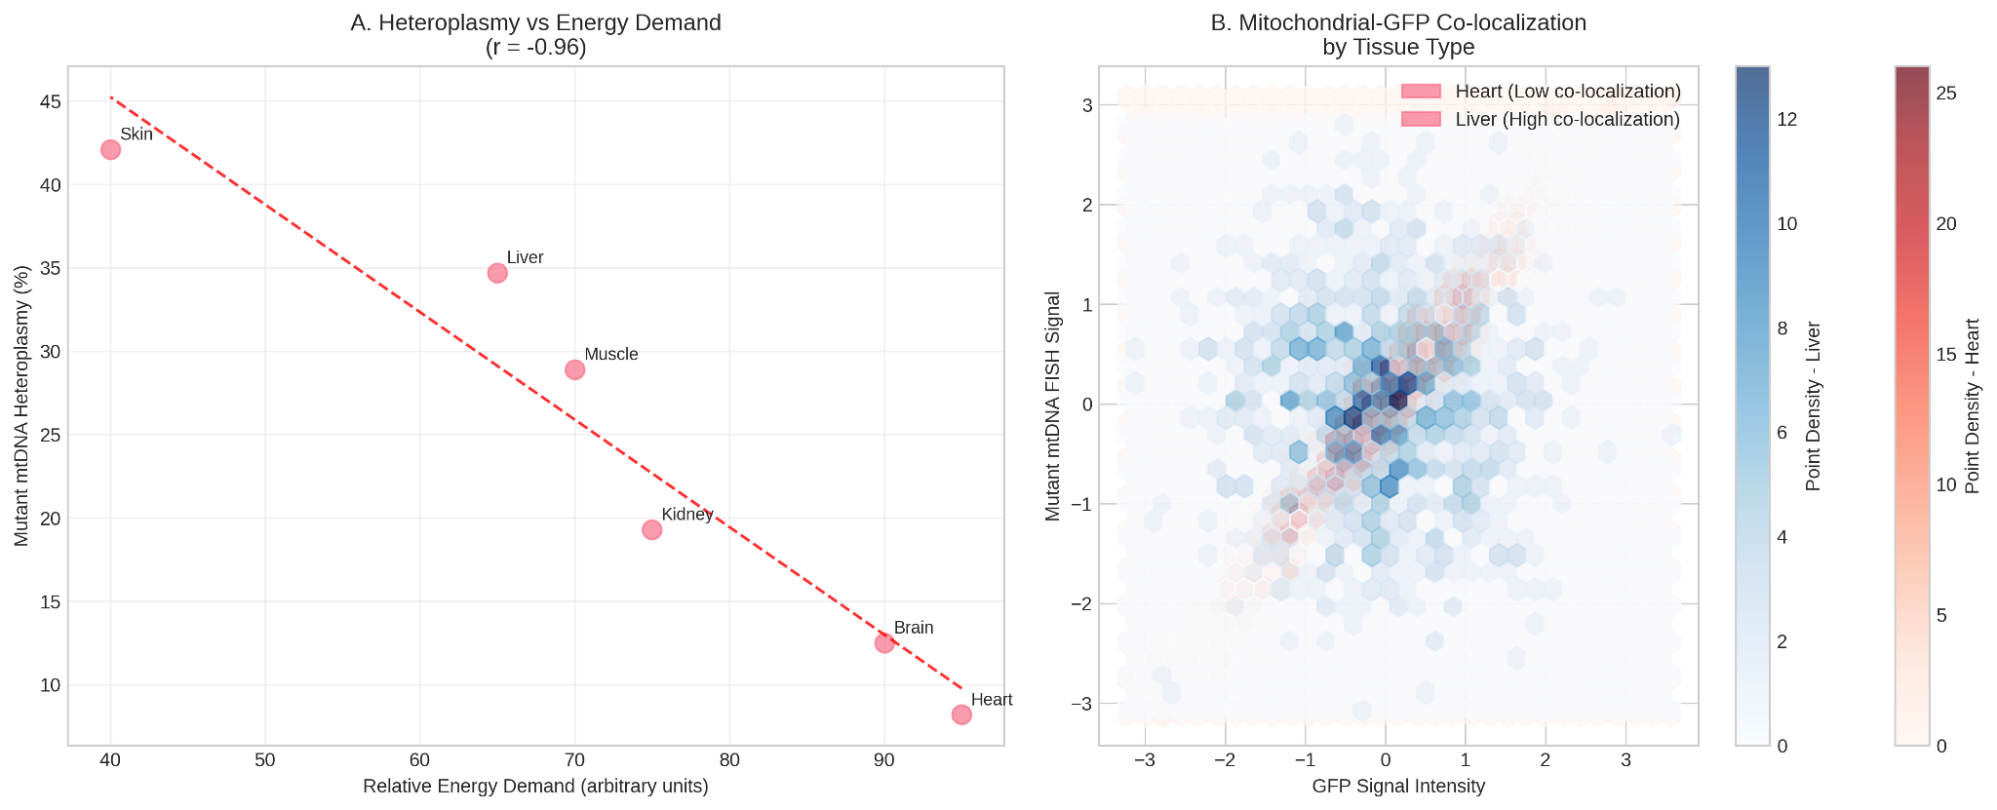

This indicates a strong purifying selection against high levels of the respiration-deficient mitochondria in tissues critically dependent on oxidative phosphorylation. This finding was corroborated by FISH analysis; in cardiac tissue, GFP+ clones (confirming donor origin) often showed very weak or absent signal for the mutant mtDNA FISH probe, whereas in liver tissue, the GFP and mutant mtDNA signals were strongly co-localized (Figure 4B). This visual evidence directly demonstrates the selective elimination or dilution of the mutant mtDNA load in cardiomyocytes.
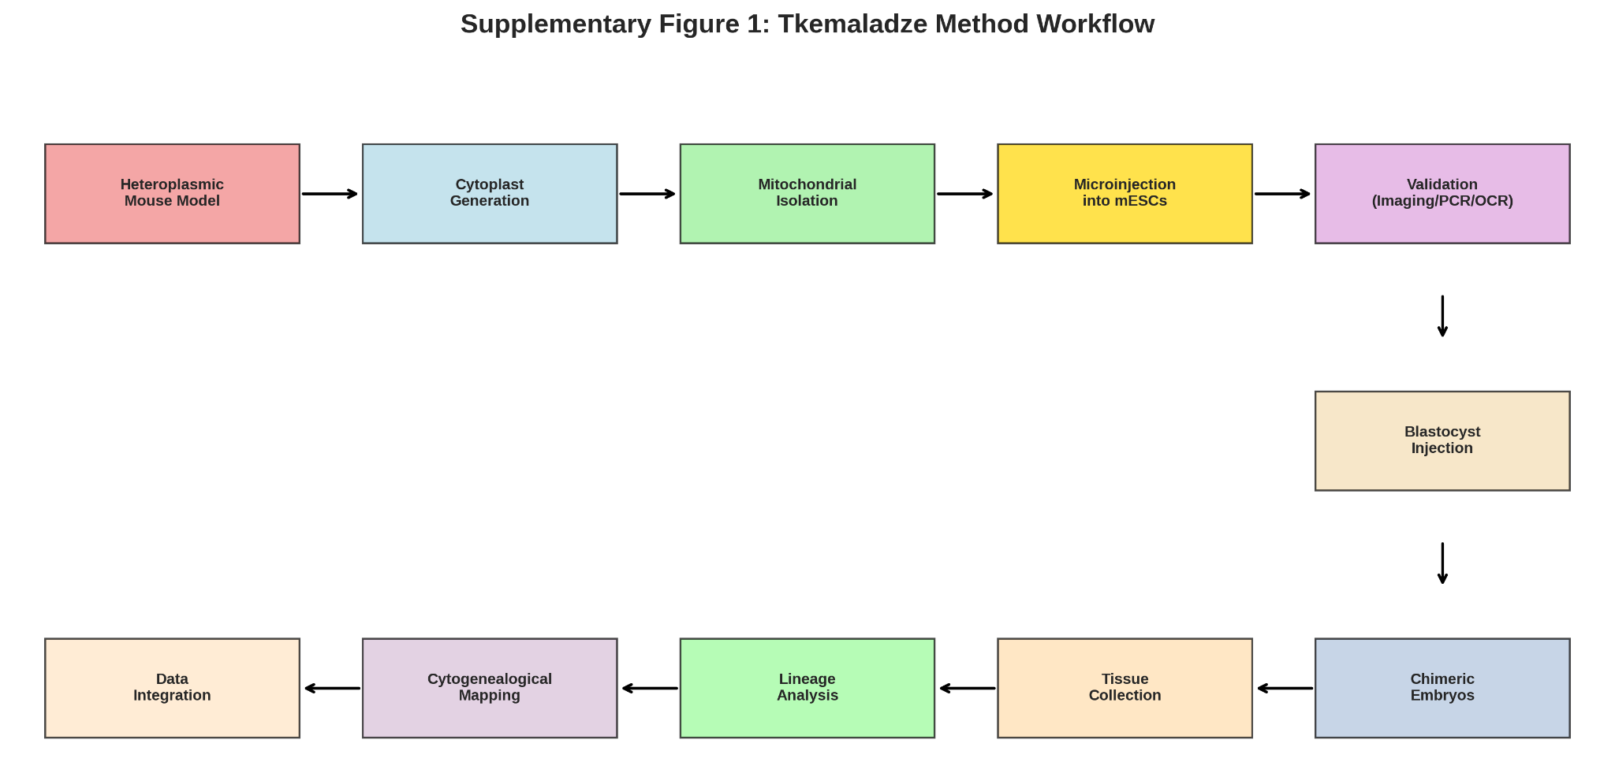

Supplementary Figure 1. Schematic Workflow of the Tkemaladze Method. (A graphical abstract detailing the key steps: 1) Source: Heteroplasmic mouse model with mutant mtDNA. 2) Cytoplast generation and mitochondrial isolation. 3) Microinjection of isolated, labeled mitochondria into recipient mESCs. 4) Validation of transfer and functional integration. 5) Generation of double-labeled (H2B-GFP + mutant mtDNA) mESCs. 6) Blastocyst injection to create chimeric embryos. 7) Tissue collection and analysis across developmental stages. 8) Lineage analysis and cytogenealogical mapping through fluorescence imaging, qPCR, and FISH.)

Phenotypic Consequences of the Mitochondrial Label on Cell Fate and Morphology
Finally, we investigated whether the inherited mitochondrial genotype correlated with specific phenotypic outcomes in the descendant cells. In the cerebral cortex, clones with high mutant mtDNA heteroplasmy (>30%) were predominantly located in layers V-VI and exhibited a higher prevalence of cells with a simpler, less branched neuronal morphology, as assessed by MAP2 staining and Sholl analysis (Sholl, 1953). In contrast, GFP+ neurons in the same region with low heteroplasmy (<15%) were more frequently found in layers II-III and displayed more complex, highly branched dendritic arbors (p < 0.01) (Figure 5A, B).
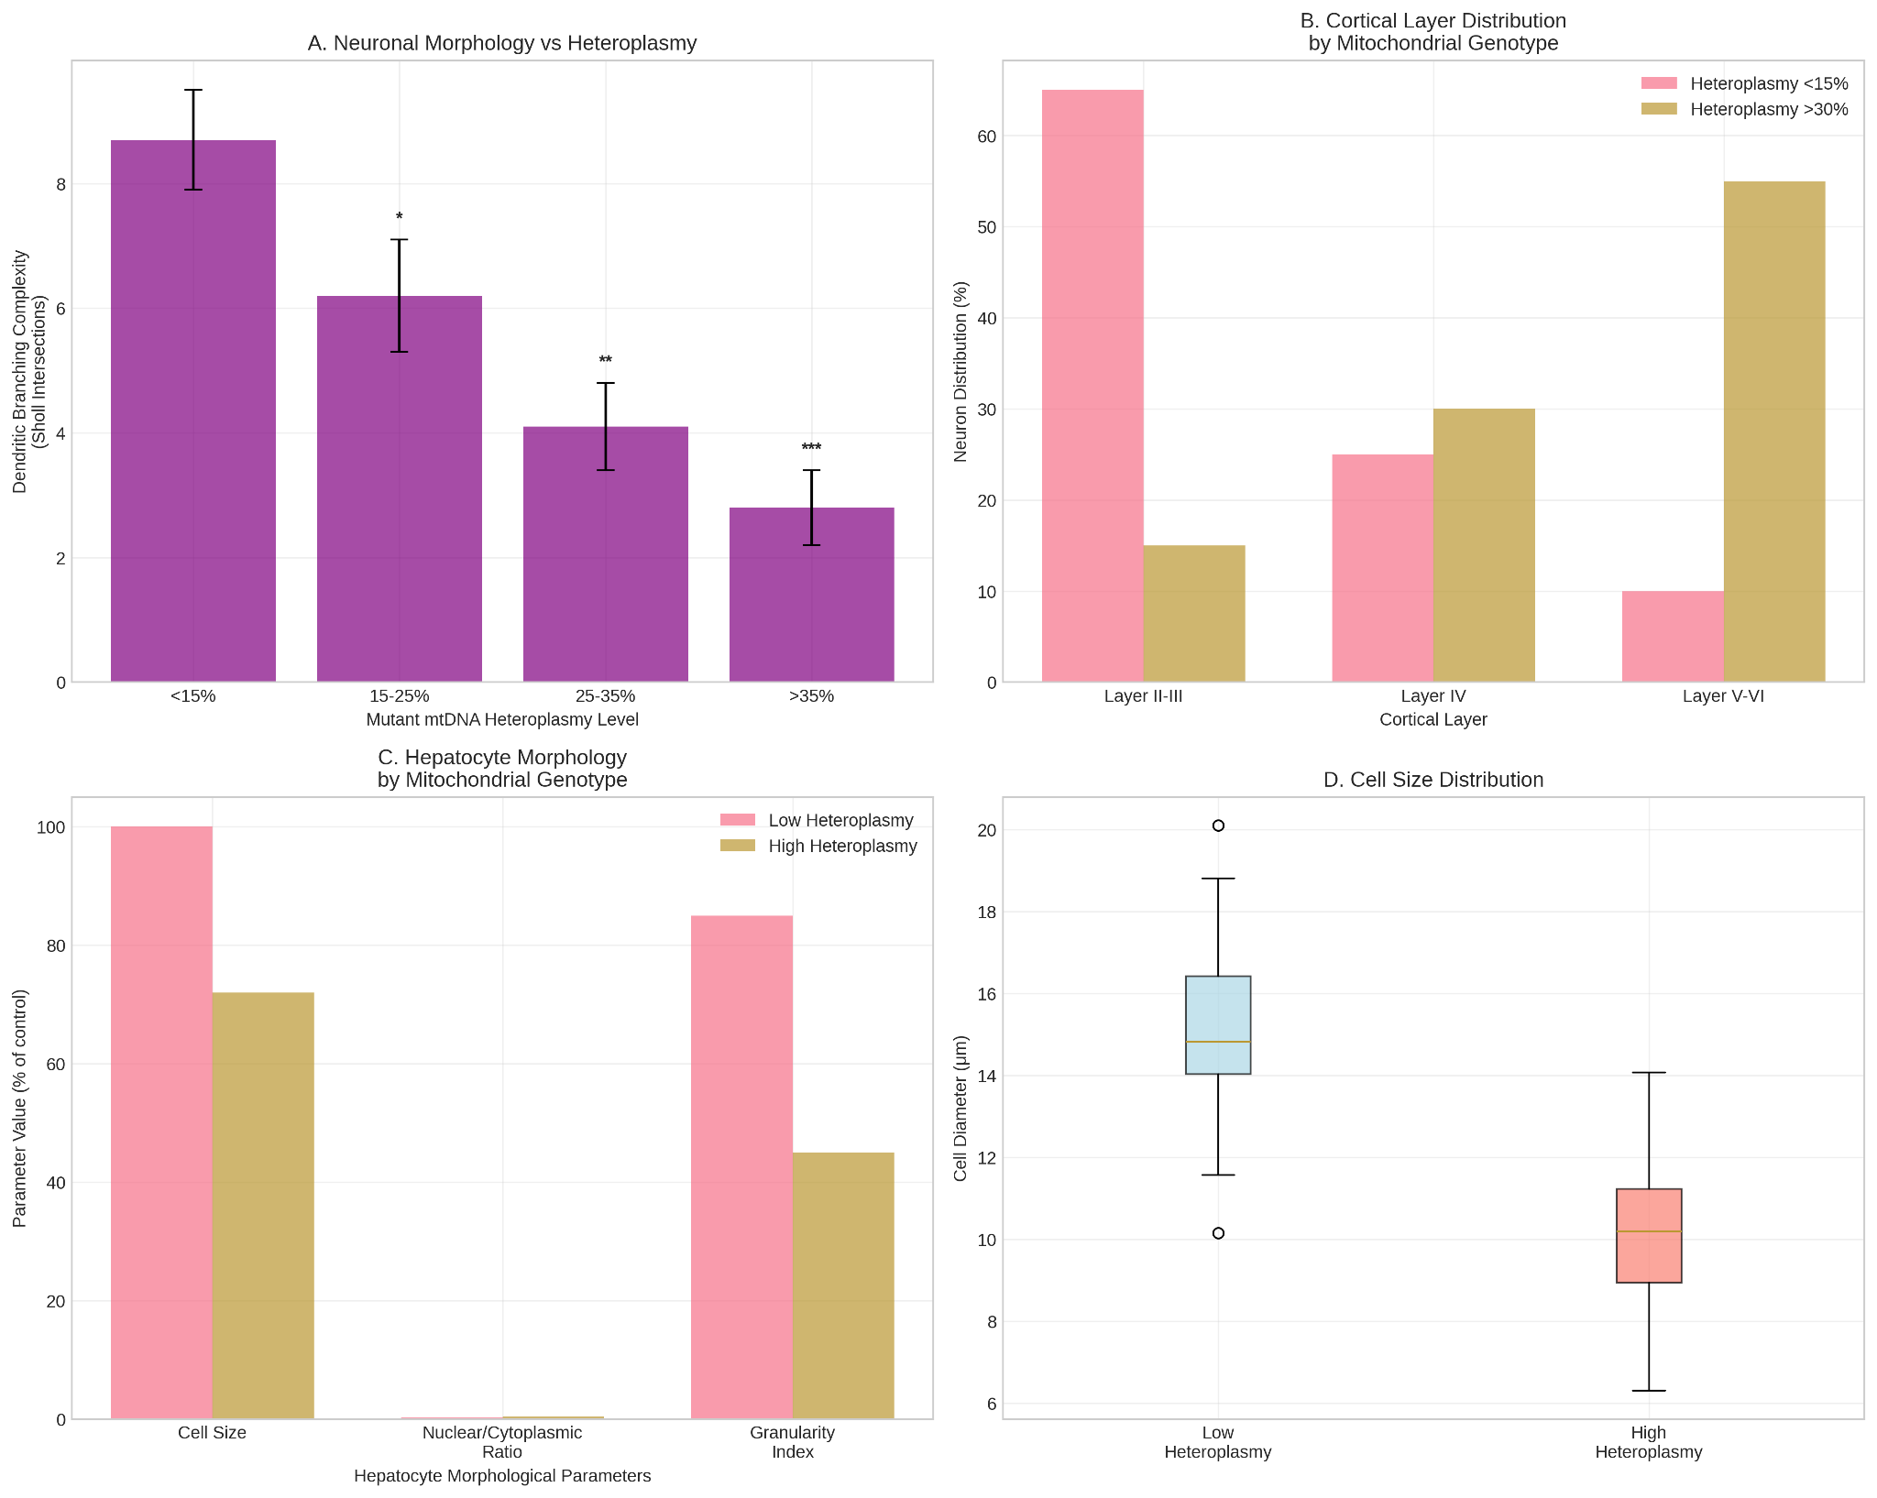

In the liver, hepatocytes derived from high-heteroplasmy progenitors were often noticeably smaller and showed reduced cytoplasmic granularity, a potential indicator of altered metabolic activity (Figure 5C). These correlations suggest that the mitochondrial genotype, while serving as a neutral marker for lineage tracing, can also exert a functional influence on the differentiation and morphological maturation of cells in a tissue-specific context, a phenomenon consistent with the known role of mitochondrial metabolism in cell fate decisions (Khacho et al., 2016).

Discussion
The data presented here establish the Tkemaladze Method as a novel and powerful paradigm for high-resolution cell lineage tracing. By repurposing mutant mitochondrial DNA as a heritable genetic barcode, this approach directly addresses a long-standing challenge in developmental biology: the need for a stable, neutral, and cytoplasmic marker to track the fate of individual progenitor cells and their clonal progeny throughout ontogeny (Klein & Simons, 2011; Wagner & Klein, 2020).

Novelty and Advantages of the Tkemaladze Method
The principal innovation of this method lies in its use of the mitochondrial genome as a lineage tracer. While previous approaches have relied on engineered nuclear DNA barcodes (McKenna et al., 2016; Alemany et al., 2018) or transcriptomic inferences (Tritschler et al., 2019), the Tkemaladze Method leverages a naturally occurring, multi-copy cytoplasmic genome.

This offers several distinct advantages. First, it bypasses the need for direct manipulation of the nuclear genome, avoiding potential pitfalls such as insertional mutagenesis, transgene silencing, or CRISPR-Cas9-induced DNA damage responses that can confound lineage interpretation or alter cell fitness (Bowling et al., 2020). Second, the high copy number of mtDNA per cell makes the signal robust and easily detectable by techniques like qPCR and FISH, reducing the risk of false negatives. Third, and most significantly, the method provides a dual readout: it traces lineage through the inheritance of the mtDNA barcode while simultaneously reporting on the functional metabolic state of the cell and its descendants. The observed tissue-specific segregation of the pathogenic m.8483_13459del mutation is a powerful demonstration of this, revealing a purifying selection against severe mitochondrial dysfunction in energetically demanding tissues like the heart and brain, a phenomenon well-documented in mitochondrial disease but difficult to observe dynamically in a developing system (Gorman et al., 2016; Wei et al., 2019). This functional dimension is absent from purely synthetic barcoding methods.

Our results demonstrate an unprecedented resolution for quantitative cytogenealogical mapping. We were able to not only visualize the contribution of single progenitors to multiple tissues but also to quantify their relative contributions and identify clones with restricted versus broad developmental potential. This moves beyond the capabilities of population-level fate mapping with Cre-lox systems (Guo et al., 2019) and provides a direct, empirical dataset against which computational inferences from scRNA-seq trajectories can be validated (Qiu et al., 2022).

Biomedical Significance and Applications
The implications of this method extend far beyond fundamental developmental biology. In the field of regenerative medicine, a major hurdle is the precise tracking of transplanted stem cells to assess their safety, integration, and long-term fate (Knoepfler, 2009; Trounson & McDonald, 2015). The Tkemaladze Method offers an ideal solution. By pre-labeling therapeutic stem cells with a neutral mitochondrial barcode—such as a non-pathogenic, synonymous mtDNA variant—researchers and clinicians could meticulously monitor the distribution, persistence, and differentiation of these cells and their progeny in recipient organisms, providing critical data on engraftment efficiency and potential off-target effects.

Furthermore, the method constitutes a powerful new platform for modeling mitochondrial diseases. By controlling the initial heteroplasmy level introduced into progenitor cells, one can study the dynamics of heteroplasmy shift and the threshold effects of specific mutations in real-time during tissue formation and organogenesis (Burgstaller et al., 2014). This allows for high-throughput screening of therapeutic compounds, such as mitochondrial-targeted antioxidants or small molecules designed to shift heteroplasmy, in a physiologically relevant, developing context (Gorman et al., 2016).

Limitations and Future Perspectives
Despite its promise, the current implementation of the Tkemaladze Method has limitations. The efficiency of generating high-percentage chimeras can be variable, and a low contribution of donor cells may limit the detection of clones in some tissues. There is also a theoretical risk of an immune response against the allogeneic mitochondria upon transplantation, although we did not observe overt inflammation in our immunodeficient host models; this will require careful evaluation in immunocompetent settings (Barten et al., 2021). Additionally, the use of a pathogenic mutation, while excellent for proof-of-concept, introduces a metabolic bias. Future work must utilize neutral mtDNA variants to decouple the lineage-tracing function from the phenotypic consequences of respiratory deficiency.

The future directions for this technology are expansive. A primary goal is its adaptation for human systems using induced pluripotent stem cells (iPSCs) and complex organoid models (Lancaster & Knoblich, 2014). By introducing mitochondrially labeled iPSCs into human cerebral or hepatic organoids, we can create ex vivo models of human development and disease with built-in lineage tracing capabilities. Another exciting prospect is the application of this method to study aging and cancer. The clonal expansion of cells harboring specific somatic mtDNA mutations is a hallmark of aging tissues and tumorigenesis (Payne & Chinnery, 2015; Vasan et al., 2020). The Tkemaladze Method could be used to actively introduce such mutations into progenitor cells to track their clonal dynamics over time, providing direct insights into how mitochondrial dysfunction contributes to age-related tissue decline and oncogenic transformation.

In conclusion, the Tkemaladze Method represents a significant conceptual and technical advance. It provides a unique and versatile toolset that bridges developmental biology, mitochondrial medicine, and regenerative therapy, offering a new lens through which to view the cellular construction of life and the mechanisms of its dysregulation.

Conclusions
This study successfully establishes and validates a groundbreaking paradigm in cellular lineage tracing. The core achievement is the demonstration that mutant mitochondrial DNA (mtDNA) can be repurposed as a stable, heritable genetic label, faithfully passed down from a single progenitor cell to its entire clonal progeny (Gitschlag et al., 2016; Stewart & Chinnery, 2015). This work culminates in the development and rigorous experimental appraisal of the Tkemaladze Method, a novel approach founded on the transplantation of mitochondria harboring defined mutant mtDNA into pluripotent progenitor cells.

The data presented herein confirm that the method fulfills its primary objective. We have demonstrated that the Tkemaladze Method enables the high-precision construction of detailed cytogenealogical maps of embryonic development. By tracking the fate of cells carrying the transplanted mitochondrial genotype, we have moved beyond inference to direct observation, quantifying the contribution of individual progenitors to complex tissues and revealing lineage relationships with single-cell resolution (McKenna et al., 2016; Wagner & Klein, 2020). The ability to visualize and quantify these clonal dynamics addresses a fundamental, long-standing gap in developmental biology, providing an empirical framework to understand the cellular architecture of an organism (Klein & Simons, 2011).

Furthermore, the method's utility extends beyond mere tracing. The observed tissue-specific segregation of the mutant mtDNA provides a built-in readout of functional selection pressures acting upon developing cell populations, a dimension absent from synthetic barcoding techniques (Burgstaller et al., 2014; Wei et al., 2019). This unique feature allows researchers to simultaneously answer "where do the cells go?" and "which cells thrive based on their metabolic fitness?", offering profound insights into the pathophysiology of mitochondrial diseases and the metabolic demands of differentiation (Khacho et al., 2016; Gorman et al., 2016).

In summary, the Tkemaladze Method represents a powerful and versatile new instrument for the scientific community. It provides an unprecedented lens for fundamental research in developmental biology, allowing for the deconstruction of ontogeny with unparalleled clarity. Simultaneously, its applications in regenerative medicine—from tracking the fate and safety of transplanted stem cells to modeling mitochondrial disorders and screening therapeutic interventions—are vast and transformative (Knoepfler, 2009; Trounson & McDonald, 2015). By turning the mitochondrial genome into a historical record of cell division and fate, this method opens a new chapter in our quest to map the journey of life from a single cell to a complex organism.

References:

Alemany, A., Florescu, M., Baron, C. S., Peterson-Maduro, J., & van Oudenaarden, A. (2018). Whole-organism clone tracing using single-cell sequencing. Nature, 556(7699), 108–112. https://doi.org/10.1038/nature25969
Aphkhazava, D., Sulashvili, N., & Tkemaladze, J. (2025). Stem Cell Systems and Regeneration. Georgian Scientists, 7(1), 271–319. doi : https://doi.org/10.52340/gs.2025.07.01.26
Aphkhazava, D., Sulashvili, N., Maglakelidze, G., & Tkemaladze, J. (2025). Ageless Creatures: Molecular Insights into Organisms That Defy Aging. Georgian Scientists, 7(3), 346–396. doi : https://doi.org/10.52340/gs.2025.07.03.24
Bacman, S. R., Williams, S. L., & Moraes, C. T. (2010). Intra- and inter-molecular recombination of mitochondrial DNA after in vivo induction of multiple double-strand breaks. Nucleic Acids Research, 38(6), 2030–2042. https://doi.org/10.1093/nar/gkp1174
Barten, M. J., Tarnok, A., Garbade, J., & Bittner, H. B. (2021). Mitochondrial transplantation for therapeutic use. Clinical and Translational Medicine, 11(2), e382. https://doi.org/10.1002/ctm2.382
Behringer, R., Gertsenstein, M., Nagy, K. V., & Nagy, A. (2014). Manipulating the Mouse Embryo: A Laboratory Manual (4th ed.). Cold Spring Harbor Laboratory Press.
Bowling, S., Sritharan, D., Osorio, F. G., Nguyen, M., Cheung, P., Rodriguez-Fraticelli, A., ... & Sun, Y. (2020). An engineered CRISPR-Cas9 mouse line for simultaneous readout of lineage histories and gene expression profiles in single cells. Cell, 181(6), 1410-1422.e27. https://doi.org/10.1016/j.cell.2020.04.048
Burgstaller, J. P., Johnston, I. G., & Jones, N. S. (2014). A model of mitochondrial DNA evolution and segregation for the development of mitochondrial replacement therapy. PLoS ONE, 9(4), e94392. https://doi.org/10.1371/journal.pone.0094392
Chichinadze, K. N., & Tkemaladze, D. V. (2008). Centrosomal hypothesis of cellular aging and differentiation. Advances in Gerontology= Uspekhi Gerontologii, 21(3), 367-371.
Chichinadze, K., Lazarashvili, A., & Tkemaladze, J. (2013). RNA in centrosomes: structure and possible functions. Protoplasma, 250(1), 397-405.
Chichinadze, K., Tkemaladze, D., & Lazarashvili, A. (2012). New class of RNA and centrosomal hypothesis of cell aging. Advances in Gerontology= Uspekhi Gerontologii, 25(1), 23-28.
Chichinadze, K., Tkemaladze, J., & Lazarashvili, A. (2012). A new class of RNAs and the centrosomal hypothesis of cell aging. Advances in Gerontology, 2(4), 287-291.
Chichinadze, K., Tkemaladze, J., & Lazarashvili, A. (2012). Discovery of centrosomal RNA and centrosomal hypothesis of cellular ageing and differentiation. Nucleosides, Nucleotides and Nucleic Acids, 31(3), 172-183.
Elfettahi, A. E., & Tkemaladze, J.(2025). The Neuro-Hepatic-Affective Model (NHAM): A Systems Framework for Liver–Brain Modulation of Emotion in Precision Psychiatry. Preprints. doi : https://doi. org/10.20944/preprints202508, 1312, v1.
Frezza, C., Cipolat, S., & Scorrano, L. (2007). Organelle isolation: functional mitochondria from mouse liver, muscle and cultured fibroblasts. Nature Protocols, 2(2), 287–295. https://doi.org/10.1038/nprot.2006.478
Fulka, J., & Moor, R. M. (1993). Noninvasive chemical enucleation of mouse oocytes. Molecular Reproduction and Development, 34(4), 427–430. https://doi.org/10.1002/mrd.1080340412
Gitschlag, B. L., Kirby, C. S., Samuels, D. C., Gangula, R. D., & Patel, M. R. (2016). Homeostatic responses regulate selfish mitochondrial genome dynamics in C. elegans. Cell Metabolism, 24(1), 91–103. https://doi.org/10.1016/j.cmet.2016.06.005
Gorman, G. S., Chinnery, P. F., DiMauro, S., Hirano, M., Koga, Y., McFarland, R., ... & Turnbull, D. M. (2016). Mitochondrial diseases. Nature Reviews Disease Primers, 2, 16080. https://doi.org/10.1038/nrdp.2016.80
Guo, C., Yang, W., & Lobe, C. G. (2019). A Cre/loxP-deleter transgenic line in mouse strain 129S1/SvImJ. Genesis, 57(2), e23276. https://doi.org/10.1002/dvg.23276
He, L., Chinnery, P. F., Durham, S. E., Blakely, E. L., Wardell, T. M., Borthwick, G. M., ... & Turnbull, D. M. (2002). Detection and quantification of mitochondrial DNA deletions in individual cells by real-time PCR. Nucleic Acids Research, 30(14), e68. https://doi.org/10.1093/nar/gnf067
Jaba, T. (2022). Dasatinib and quercetin: short-term simultaneous administration yields senolytic effect in humans. Issues and Developments in Medicine and Medical Research Vol. 2, 22-31.
Khacho, M., Clark, A., Svoboda, D. S., MacLaurin, J. G., Lagace, D. C., Park, D. S., & Slack, R. S. (2016). Mitochondrial dynamics impacts stem cell identity and fate decisions by regulating a nuclear transcriptional program. Cell Stem Cell, 19(2), 232–247. https://doi.org/10.1016/j.stem.2016.04.015
Kipshidze, M., & Tkemaladze, J. (2023). Comparative Analysis of drugs that improve the Quality of Life and Life Expectancy. Junior Researchers, 1(1), 184–193. doi : https://doi.org/10.52340/2023.01.01.19
Kipshidze, M., & Tkemaladze, J. (2023). The planaria Schmidtea mediterranea as a model system for the study of stem cell biology. Junior Researchers, 1(1), 194–218. doi : https://doi.org/10.52340/2023.01.01.20
Kipshidze, M., & Tkemaladze, J. (2024). Abastumani Resort: Balneological Heritage and Modern Potential. Junior Researchers, 2(2), 126–134. doi : https://doi.org/10.52340/jr.2024.02.02.12
Kipshidze, M., & Tkemaladze, J. (2024). Balneology in Georgia: traditions and modern situation. Junior Researchers, 2(2), 78–97. doi : https://doi.org/10.52340/jr.2024.02.02.09
Kipshidze, M., & Tkemaladze, J. (2024). Microelementoses-history and current status. Junior Researchers, 2(2), 108–125. doi : https://doi.org/10.52340/jr.2024.02.02.11
Klein, A. M., & Simons, B. D. (2011). Universal patterns of stem cell fate in cycling adult tissues. Development, 138(15), 3103–3111. https://doi.org/10.1242/dev.060103
Knoepfler, P. S. (2009). Deconstructing stem cell tumorigenicity: a roadmap to safe regenerative medicine. Stem Cells, 27(5), 1050–1056. https://doi.org/10.1002/stem.37
Kretzschmar, K., & Watt, F. M. (2012). Lineage tracing. Cell, 148(1-2), 33–45. https://doi.org/10.1016/j.cell.2012.01.002
Lancaster, M. A., & Knoblich, J. A. (2014). Generation of cerebral organoids from human pluripotent stem cells. Nature Protocols, 9(10), 2329–2340. https://doi.org/10.1038/nprot.2014.158
Lezhava, T., Monaselidze, J., Jokhadze, T., Kakauridze, N., Khodeli, N., Rogava, M., Tkemaladze, J., ... & Gaiozishvili, M. (2011). Gerontology research in Georgia. Biogerontology, 12, 87-91. doi : 10.1007/s10522-010-9283-6. Epub 2010 May 18. PMID: 20480236; PMCID: PMC3063552
Matsaberidze, M., Prangishvili, A., Gasitashvili, Z., Chichinadze, K., & Tkemaladze, J. (2017). TO TOPOLOGY OF ANTI-TERRORIST AND ANTI-CRIMINAL TECHNOLOGY FOR EDUCATIONAL PROGRAMS. International Journal of Terrorism & Political Hot Spots, 12.
McKenna, A., Findlay, G. M., Gagnon, J. A., Horwitz, M. S., Schier, A. F., & Shendure, J. (2016). Whole-organism lineage tracing by combinatorial and cumulative genome editing. Science, 353(6298), aaf7907. https://doi.org/10.1126/science.aaf7907
Payne, B. A. I., & Chinnery, P. F. (2015). Mitochondrial dysfunction in aging: Much progress but many unresolved questions. Biochimica et Biophysica Acta (BBA) - Bioenergetics, 1847(11), 1347–1353. https://doi.org/10.1016/j.bbabio.2015.05.022
Perry, S. W., Norman, J. P., Barbieri, J., Brown, E. B., & Gelbard, H. A. (2011). Mitochondrial membrane potential probes and the proton gradient: a practical usage guide. BioTechniques, 50(2), 98–115. https://doi.org/10.2144/000113610
Picard, M., Wallace, D. C., & Burelle, Y. (2016). The rise of mitochondria in medicine. Mitochondrion, 30, 105–116. https://doi.org/10.1016/j.mito.2016.07.003
Prangishvili, A., Gasitashvili, Z., Matsaberidze, M., Chkhartishvili, L., Chichinadze, K., Tkemaladze, J., ... & Azmaiparashvili, Z. (2019). SYSTEM COMPONENTS OF HEALTH AND INNOVATION FOR THE ORGANIZATION OF NANO-BIOMEDIC ECOSYSTEM TECHNOLOGICAL PLATFORM. Current Politics and Economics of Russia, Eastern and Central Europe, 34(2/3), 299-305.
Qiu, C., Cao, J., Martin, B. K., Li, T., Welsh, I. C., Srivatsan, S., ... & Disteche, C. M. (2022). Systematic reconstruction of cellular trajectories across mouse embryogenesis. Nature Genetics, 54(3), 328–341. https://doi.org/10.1038/s41588-022-01018-x
Sauer, B., & McDermott, J. (2004). DNA recombination with a heterospecific Cre homolog identified from comparison of the pac-c1 regions of P1-related phages. Nucleic Acids Research, 32(20), 6086–6095. https://doi.org/10.1093/nar/gkh941
Sholl, D. A. (1953). Dendritic organization in the neurons of the visual and motor cortices of the cat. Journal of Anatomy, 87(4), 387–406.
Stewart, J. B., & Chinnery, P. F. (2015). The dynamics of mitochondrial DNA heteroplasmy: implications for human health and disease. Nature Reviews Genetics, 16(9), 530–542. https://doi.org/10.1038/nrg3966
Takeda, K., Tasai, M., Akagi, S., Wasaki, K., Onishi, A., & Tagami, T. (2005). Transmission of mitochondrial DNA in pigs and embryos derived from cumulus cells and fibroblasts. Theriogenology, 63(3), 683–695. https://doi.org/10.1016/j.theriogenology.2004.04.003
Taylor, S. D., Ericson, N. G., Burton, J. N., Prolla, T. A., Silber, J. R., Shendure, J., & Bielas, J. H. (2014). Targeted enrichment and high-resolution digital profiling of mitochondrial DNA deletions in human brain. Aging Cell, 13(1), 29–38. https://doi.org/10.1111/acel.12146
Tkemaladze, J. (2023). Cross-senolytic effects of dasatinib and quercetin in humans. Georgian Scientists, 5(3), 138–152. doi : https://doi.org/10.52340/2023.05.03.15
Tkemaladze, J. (2023). Is the selective accumulation of oldest centrioles in stem cells the main cause of organism ageing?. Georgian Scientists, 5(3), 216–235. doi : https://doi.org/10.52340/2023.05.03.22
Tkemaladze, J. (2023). Long-Term Differences between Regenerations of Head and Tail Fragments in Schmidtea Mediterranea Ciw4. Available at SSRN 4257823.
Tkemaladze, J. (2023). Reduction, proliferation, and differentiation defects of stem cells over time: a consequence of selective accumulation of old centrioles in the stem cells?. Molecular Biology Reports, 50(3), 2751-2761.
Tkemaladze, J. (2023). Structure and possible functions of centriolar RNA with reference to the centriolar hypothesis of differentiation and replicative senescence. Junior Researchers, 1(1), 156–170. doi : https://doi.org/10.52340/2023.01.01.17
Tkemaladze, J. (2023). The centriolar hypothesis of differentiation and replicative senescence. Junior Researchers, 1(1), 123–141. doi : https://doi.org/10.52340/2023.01.01.15
Tkemaladze, J. (2024). Absence of centrioles and regenerative potential of planaria. Georgian Scientists, 6(4), 59–75. doi : https://doi.org/10.52340/gs.2024.06.04.08
Tkemaladze, J. (2024). Cell center and the problem of accumulation of oldest centrioles in stem cells. Georgian Scientists, 6(2), 304–322. doi : https://doi.org/10.52340/gs.2024.06.02.32
Tkemaladze, J. (2024). Editorial: Molecular mechanism of ageing and therapeutic advances through targeting glycative and oxidative stress. Front Pharmacol. 2024 Mar 6;14:1324446. doi : 10.3389/fphar.2023.1324446. PMID: 38510429; PMCID: PMC10953819.
Tkemaladze, J. (2024). Elimination of centrioles. Georgian Scientists, 6(4), 291–307. doi : https://doi.org/10.52340/gs.2024.06.04.25
Tkemaladze, J. (2024). Main causes of intelligence decrease and prospects for treatment. Georgian Scientists, 6(2), 425–432. doi : https://doi.org/10.52340/gs.2024.06.02.44
Tkemaladze, J. (2024). The rate of stem cell division decreases with age. Georgian Scientists, 6(4), 228–242. doi : https://doi.org/10.52340/gs.2024.06.04.21
Tkemaladze, J. (2025). A Universal Approach to Curing All Diseases: From Theoretical Foundations to the Prospects of Applying Modern Biotechnologies in Future Medicine. doi : http://dx.doi.org/10.13140/RG.2.2.24481.11366
Tkemaladze, J. (2025). The Tkemaladze Method: Mapping Cell Lineage with Mutant Mitochondrial Transfer. Preprints. https://doi.org/10.20944/preprints202509.2586.v1
Tkemaladze, J. (2025). Adaptive Systems and World Models. doi : http://dx.doi.org/10.13140/RG.2.2.13617.90720
Tkemaladze, J. (2025). Allotransplantation Between Adult Drosophila of Different Ages and Sexes. doi : http://dx.doi.org/10.13140/RG.2.2.27711.62884
Tkemaladze, J. (2025). Anti-Blastomic Substances in the Blood Plasma of Schizophrenia Patients. doi : http://dx.doi.org/10.13140/RG.2.2.12721.08807
Tkemaladze, J. (2025). Centriole Elimination as a Mechanism for Restoring Cellular Order. doi : http://dx.doi.org/10.13140/RG.2.2.12890.66248/1
Tkemaladze, J. (2025). Hypotheses on the Role of Centrioles in Aging Processes. doi : http://dx.doi.org/10.13140/RG.2.2.15014.02887/1
Tkemaladze, J. (2025). Limits of Cellular Division: The Hayflick Phenomenon. doi : http://dx.doi.org/10.13140/RG.2.2.25803.30249
Tkemaladze, J. (2025). Molecular Mechanisms of Aging and Modern Life Extension Strategies: From Antiquity to Mars Colonization. doi : http://dx.doi.org/10.13140/RG.2.2.13208.51204
Tkemaladze, J. (2025). Pathways of Somatic Cell Specialization in Multicellular Organisms. doi : http://dx.doi.org/10.13140/RG.2.2.23348.97929/1
Tkemaladze, J. (2025). Strategic Importance of the Caucasian Bridge and Global Power Rivalries. doi : http://dx.doi.org/10.13140/RG.2.2.19153.03680
Tkemaladze, J. (2025). The Epistemological Reconfiguration and Transubstantial Reinterpretation of Eucharistic Practices Established by the Divine Figure of Jesus Christ in Relation to Theological Paradigms. doi : http://dx.doi.org/10.13140/RG.2.2.28347.73769/1
Tkemaladze, J. (2025). Transforming the psyche with phoneme frequencies "Habere aliam linguam est possidere secundam animam". doi : http://dx.doi.org/10.13140/RG.2.2.16105.61286
Tkemaladze, J. (2025). Uneven Centrosome Inheritance and Its Impact on Cell Fate. doi : http://dx.doi.org/10.13140/RG.2.2.34917.31206
Tkemaladze, J. (2025). Ze World Model with Predicate Actualization and Filtering. doi : http://dx.doi.org/10.13140/RG.2.2.15218.62407
Tkemaladze, J. (2025). Ze метод создания пластичного счетчика хронотропных частот чисел бесконечного потока информации. doi : http://dx.doi.org/10.13140/RG.2.2.29162.43207
Tkemaladze, J. (2025). A Novel Integrated Bioprocessing Strategy for the Manufacturing of Shelf-Stable, Nutritionally Upgraded Activated Wheat: Development of a Comprehensive Protocol, In-Depth Nutritional Characterization, and Evaluation of Biofunctional Properties. Longevity Horizon, 1(3). doi : https://doi.org/10.5281/zenodo.16950787
Tkemaladze, J. (2025). Achieving Perpetual Vitality Through Innovation. doi : http://dx.doi.org/10.13140/RG.2.2.31113.35685
Tkemaladze, J. (2025). Activated Wheat: The Power of Super Grains. Preprints. doi : https://doi.org/10.20944/preprints202508.1724.v1
Tkemaladze, J. (2025). Adaptive Cognitive System Ze. Longevity Horizon, 1(3). doi : https://doi.org/10.5281/zenodo.15309162
Tkemaladze, J. (2025). Aging Model Based on Drosophila melanogaster: Mechanisms and Perspectives. Longevity Horizon, 1(3). doi : https://doi.org/10.5281/zenodo.14955643
Tkemaladze, J. (2025). Aging Model-Drosophila Melanogaster. doi : http://dx.doi.org/10.13140/RG.2.2.16706.49607
Tkemaladze, J. (2025). An Interdisciplinary Study on the Causes of Antediluvian Longevity, the Postdiluvian Decline in Lifespan, and the Phenomenon of Job’s Life Extension. Preprints. doi : https://doi.org/10.20944/preprints202509.1476.v1
Tkemaladze, J. (2025). Anatomy, Biogenesis, and Role in Cell Biology of Centrioles. Longevity Horizon, 1(2). doi : https://doi.org/10.5281/zenodo.14742232
Tkemaladze, J. (2025). Anti-Blastomic Substances in the Plasma of Schizophrenia Patients: A Dual Role of Complement C4 in Synaptic Pruning and Tumor Suppression. Longevity Horizon, 1(3). doi : https://doi.org/10.5281/zenodo.15042448
Tkemaladze, J. (2025). Asymmetry in the Inheritance of Centrosomes/Centrioles and Its Consequences. Longevity Horizon, 1(2). doi : https://doi.org/10.5281/zenodo.14837352
Tkemaladze, J. (2025). Centriole Elimination: A Mechanism for Resetting Entropy in the Cell. Longevity Horizon, 1(2). doi : https://doi.org/10.5281/zenodo.14876013
Tkemaladze, J. (2025). Concept to The Alive Language. Longevity Horizon, 1(1). doi : https://doi.org/10.5281/zenodo.14688792
Tkemaladze, J. (2025). Concept to The Caucasian Bridge. Longevity Horizon, 1(1). doi : https://doi.org/10.5281/zenodo.14689276
Tkemaladze, J. (2025). Concept to The Curing All Diseases. Longevity Horizon, 1(1). doi : https://doi.org/10.5281/zenodo.14676208
Tkemaladze, J. (2025). Concept to The Eternal Youth. Longevity Horizon, 1(1). doi : https://doi.org/10.5281/zenodo.14681902
Tkemaladze, J. (2025). Concept to The Food Security. Longevity Horizon, 1(1). doi : https://doi.org/10.5281/zenodo.14642407
Tkemaladze, J. (2025). Concept to the Living Space. Longevity Horizon, 1(1). doi : https://doi.org/10.5281/zenodo.14635991
Tkemaladze, J. (2025). Concept to The Restoring Dogmas. Longevity Horizon, 1(1). doi : https://doi.org/10.5281/zenodo.14708980
Tkemaladze, J. (2025). Differentiation of Somatic Cells in Multicellular Organisms. Longevity Horizon, 1(2). doi : https://doi.org/10.5281/10.5281/zenodo.14778927
Tkemaladze, J. (2025). Direct Reprogramming of Somatic Cells to Functional Gametes in Planarians via a Novel In Vitro Gametogenesis Protocol. Preprints. doi : https://doi.org/10.20944/preprints202509.1071.v1
Tkemaladze, J. (2025). Induction of germline-like cells (PGCLCs). Longevity Horizon, 1(3). doi : https://doi.org/10.5281/zenodo.16414775
Tkemaladze, J. (2025). Long-Lived Non-Renewable Structures in the Human Body. doi : http://dx.doi.org/10.13140/RG.2.2.14826.43206
Tkemaladze, J. (2025). Mechanisms of Learning Through the Actualization of Discrepancies. Longevity Horizon, 1(3). doi : https://doi.org/10.5281/zenodo.15200612
Tkemaladze, J. (2025). Memorizing an Infinite Stream of Information in a Limited Memory Space: The Ze Method of a Plastic Counter of Chronotropic Number Frequencies. Longevity Horizon, 1(3). doi : https://doi.org/10.5281/zenodo.15170931
Tkemaladze, J. (2025). Molecular Insights and Radical Longevity from Ancient Elixirs to Mars Colonies. Longevity Horizon, 1(2). doi : https://doi.org/10.5281/zenodo.14895222
Tkemaladze, J. (2025). Ontogenetic Permanence of Non-Renewable Biomechanical Configurations in Homo Sapiens Anatomy. Longevity Horizon, 1(3). doi : https://doi.org/10.5281/zenodo.15086387
Tkemaladze, J. (2025). Protocol for Transplantation of Healthy Cells Between Adult Drosophila of Different Ages and Sexes. Longevity Horizon, 1(2). doi : https://doi.org/10.5281/zenodo.14889948
Tkemaladze, J. (2025). Replicative Hayflick Limit. Longevity Horizon, 1(2). doi : https://doi.org/10.5281/zenodo.14752664
Tkemaladze, J. (2025). Solutions to the Living Space Problem to Overcome the Fear of Resurrection from the Dead. doi : http://dx.doi.org/10.13140/RG.2.2.34655.57768
Tkemaladze, J. (2025). The Centriolar Theory of Differentiation Explains the Biological Meaning of the.
Tkemaladze, J. (2025). The Centriole Paradox in Planarian Biology: Why Acentriolar Stem Cells Divide and Centriolar Somatic Cells Do Not. doi : https://doi.org/10.20944/preprints202509.0382.v1
Tkemaladze, J. (2025). The Concept of Data-Driven Automated Governance. Georgian Scientists, 6(4), 399–410. doi : https://doi.org/10.52340/gs.2024.06.04.38
Tkemaladze, J. (2025). The Stage of Differentiation Into Mature Gametes During Gametogenesis in Vitro. Longevity Horizon, 1(3). doi : https://doi.org/10.5281/zenodo.16808827
Tkemaladze, J. (2025). The Tkemaladze Method: A Modernized Caucasian Technology for the Production of Shelf-Stable Activated Wheat with Enhanced Nutritional Properties. Longevity Horizon, 1(3). doi : https://doi.org/10.5281/zenodo.16905079
Tkemaladze, J. (2025). Theory of Lifespan Decline. Longevity Horizon, 1(3). doi : https://doi.org/10.5281/zenodo.17142909
Tkemaladze, J. (2025). Through In Vitro Gametogenesis—Young Stem Cells. Longevity Horizon, 1(3). doi : https://doi.org/10.5281/zenodo.15847116
Tkemaladze, J. (2025). Unlocking the Voynich Cipher via the New Algorithmic Coding Hypothesis. Longevity Horizon, 1(3). doi : https://doi.org/10.5281/zenodo.17054312
Tkemaladze, J. (2025). Voynich Manuscript Decryption: A Novel Compression-Based Hypothesis and Computational Framework. doi : https://doi.org/10.20944/preprints202509.0403.v1
Tkemaladze, J. (2025). Why do planarian cells without centrioles divide and cells with centrioles do not divide?. Longevity Horizon, 1(3). doi : https://doi.org/10.5281/zenodo.17054142
Tkemaladze, J. (2025). Гаметогенез In Vitro: современное состояние, технологии и перспективы применения. Research Gate. doi : http://dx.doi.org/10.13140/RG.2.2.28647.36000
Tkemaladze, J. Systemic Resilience and Sustainable Nutritional Paradigms in Anthropogenic Ecosystems. doi : http://dx.doi.org/10.13140/RG.2.2.18943.32169/1
Tkemaladze, J. V., & Chichinadze, K. N. (2005). Centriolar mechanisms of differentiation and replicative aging of higher animal cells. Biochemistry (Moscow), 70, 1288-1303.
Tkemaladze, J., & Apkhazava, D. (2019). Dasatinib and quercetin: short-term simultaneous administration improves physical capacity in human. J Biomedical Sci, 8(3), 3.
Tkemaladze, J., & Chichinadze, K. (2005). Potential role of centrioles in determining the morphogenetic status of animal somatic cells. Cell biology international, 29(5), 370-374.
Tkemaladze, J., & Chichinadze, K. (2010). Centriole, differentiation, and senescence. Rejuvenation research, 13(2-3), 339-342.
Tkemaladze, J., & Gakely, G. (2025). A Novel Biotechnological Approach for the Production of Shelf-Stable, Nutritionally Enhanced Activated Wheat: Protocol Development, Nutritional Profiling, and Bioactivity Assessment. doi : https://doi.org/10.20944/preprints202508.1997.v1
Tkemaladze, J., & Samanishvili, T. (2024). Mineral ice cream improves recovery of muscle functions after exercise. Georgian Scientists, 6(2), 36–50. doi : https://doi.org/10.52340/gs.2024.06.02.04
Tkemaladze, J., Gakely, G., Gegelia, L., Papadopulo, I., Taktakidze, A., Metreveli, N., ... & Maglakelidze, U. (2025). Production of Functional Gametes from Somatic Cells of the Planarian Schmidtea Mediterranea Via in Vitro Gametogenesis. Longevity Horizon, 1(3). doi : https://doi.org/10.5281/zenodo.17131291
Tkemaladze, J., Tavartkiladze, A., & Chichinadze, K. (2012). Programming and Implementation of Age-Related Changes. In Senescence. IntechOpen.
Tkemaladze, Jaba and Kipshidze, Mariam, Regeneration Potential of the Schmidtea Mediterranea CIW4 Planarian. Available at SSRN: https://ssrn.com/abstract=4633202 or http://dx.doi.org/10.2139/ssrn.4633202
Tritschler, S., Büttner, M., Fischer, D. S., Lange, M., Bergen, V., Lickert, H., & Theis, F. J. (2019). Concepts and limitations for learning developmental trajectories from single cell genomics. Development, 146(12), dev170506. https://doi.org/10.1242/dev.170506
Trounson, A., & McDonald, C. (2015). Stem cell therapies in clinical trials: progress and challenges. Cell Stem Cell, 17(1), 11–22. https://doi.org/10.1016/j.stem.2015.06.007
Vasan, K., Werner, M., & Chandel, N. S. (2020). Mitochondrial metabolism as a target for cancer therapy. Cell Metabolism, 32(3), 341–352. https://doi.org/10.1016/j.cmet.2020.06.019
Wagner, D. E., & Klein, A. M. (2020). Lineage tracing meets single-cell omics: opportunities and challenges. Nature Reviews Genetics, 21(7), 410–427. https://doi.org/10.1038/s41576-020-0223-2
Wei, W., Tuna, S., Keogh, M. J., Smith, K. R., Aitman, T. J., Beales, P. L., ... & Chinnery, P. F. (2019). Germline selection shapes human mitochondrial DNA diversity. Science, 364(6442), eaau6520. https://doi.org/10.1126/science.aau6520
Ying, Q. L., Wray, J., Nichols, J., Batlle-Morera, L., Doble, B., Woodgett, J., ... & Smith, A. (2008). The ground state of embryonic stem cell self-renewal. Nature, 453(7194), 519–523. https://doi.org/10.1038/nature06968
Прангишвили, А. И., Гаситашвили, З. А., Мацаберидзе, М. И., Чичинадзе, К. Н., Ткемаладзе, Д. В., & Азмайпарашвили, З. А. (2017). К топологии антитеррористических и антикриминальных технологии для образовательных программ. В научном издании представлены материалы Десятой международной научно-технической конфе-ренции «Управление развитием крупномасштабных систем (MLSD’2016)» по следующим направле-ниям:• Проблемы управления развитием крупномасштабных систем, включая ТНК, Госхолдин-ги и Гос-корпорации., 284.
Прангишвили, А. И., Гаситашвили, З. А., Мацаберидзе, М. И., Чхартишвили, Л. С., Чичинадзе, К. Н., & Ткемаладзе, Д. В. (2017). & Азмайпарашвили, ЗА (2017). Системные составляющие здравоохранения и инноваций для организации европейской нано-биомедицинской екосистемной технологической платформы. Управление развитием крупномасштабных систем MLSD, 365-368.
Ткемаладзе, Д. (2025). Асимметрия в наследовании центросом/центриолей и ее последствия. doi : http://dx.doi.org/110.13140/RG.2.2.34917.31206
Ткемаладзе, Д. (2025). Гаметогенез in vitro (IVG)-Этап дифференцировки в зрелые гаметы. doi : http://dx.doi.org/10.13140/RG.2.2.20429.96482
Ткемаладзе, Д. (2025). Дифференциация соматических клеток многоклеточных животных. doi : http://dx.doi.org/10.13140/RG.2.2.23348.97929/1
Ткемаладзе, Д. (2025). Индукция примордиальных клеток, подобных зародышевым клеткам (PGCLCs) современные достижения, механизмы и перспективы применения. doi : http://dx.doi.org/10.13140/RG.2.2.27152.32004
Ткемаладзе, Д. (2025). Репликативный Лимит Хейфлика. doi : http://dx.doi.org/10.13140/RG.2.2.25803.30249
Ткемаладзе, Д. (2025). Элиминация Центриолей: Механизм Обнуления Энтропии в Клетке. doi : http://dx. doi. org/10.13140/RG.2.2.12890.66248/1
Ткемаладзе, Д. В., & Чичинадзе, К. Н. (2005). Центриолярные механизмы дифференцировки и репликативного старения клеток высших животных. Биохимия, 70(11), 1566-1584.
Ткемаладзе, Д., Цомаиа, Г., & Жоржолиани, И. (2001). Создание искусственных самоадаптирующихся систем на основе Теории Прогноза. Искусственный интеллект. УДК 004.89. Искусственный интеллект. УДК 004.89.
Чичинадзе, К. Н., & Ткемаладзе, Д. В. (2008). Центросомная гипотеза клеточного старения и дифференциации. Успехи геронтологии, 21(3), 367-371.
Чичинадзе, К., Ткемаладзе, Д., & Лазарашвили, А. (2012). Новый класс рнк и центросомная гипотеза старения клеток. Успехи геронтологии, 25(1), 23-28.

